# Lab: Modules, Babel and Transpiling

Problems for exercises and homework for the [“JavaScript Advanced” course @ SoftUni](https://softuni.bg/courses/javascript-advanced). Submit your solutions in the SoftUni judge system at <https://judge.softuni.bg/Contests/342/>.

# Submitting to Judge

For the following tasks, you will be submitting using the **JavaScript Zip File** strategy.

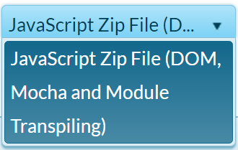

The strategy requires that you submit a **zip** file containing all your **JavaScript** (**.js**) files. Your main file should always be named app.js - it is the beginning of your program and should import/require all other files needed.

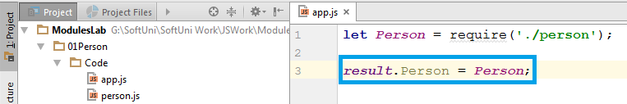

If your program is required to return a result (classes, objects, functions etc.) they need to be attached to the result object in the app.js.

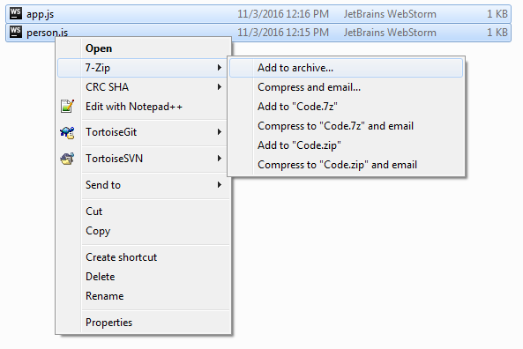

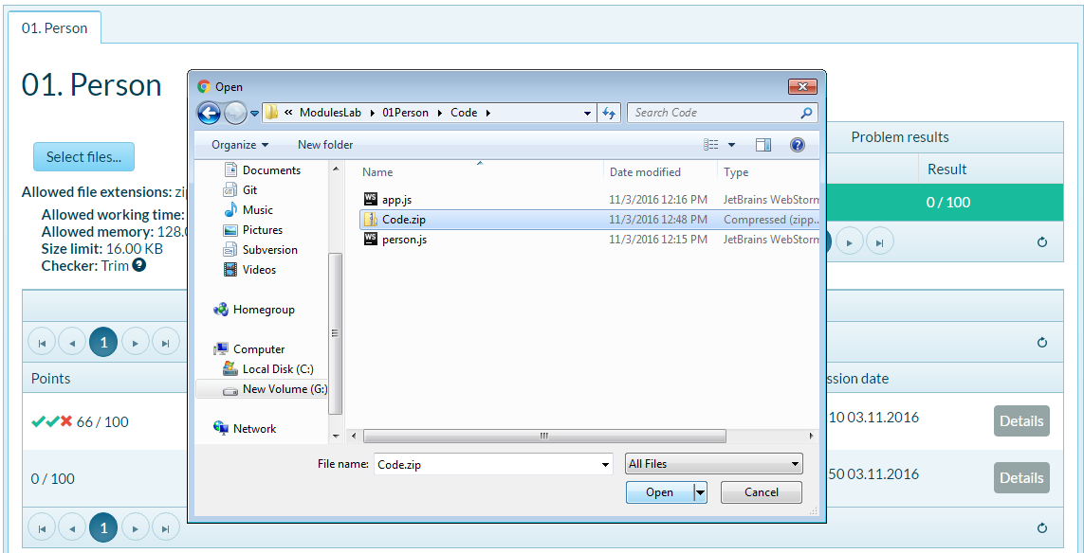

## Person Module

Write a JS module that exports a **class Person**. The Person has a name property, that is set trough the constructor and a toString() method, which returns **"I'm {name}."** as a **string**. Write an app.js file that loads the **Person** module and attaches it to the result object provided.

As an exercise, rewrite the task using all three methods for module definition (AMD, CommonJS and ES6 native).

### Screenshots

Person.js

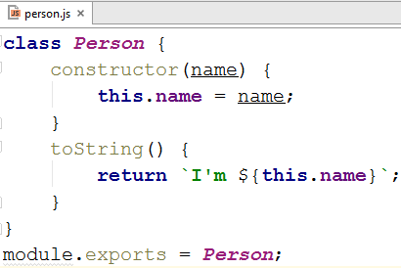

app.js

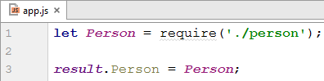

### Bonus

As an exercise, you can rewrite the task using all three methods for module definition (AMD, CommonJS and ES6 native). This part doesn't need to be submitted to the Judge system it is simply for practice.

## Sort Map

You probably wanted to be able to sort a map while going through the Fundamentals course, so we're going to make a simple program to do that. You need to return (attach to result) a method mapSort which takes in a Map and optionally a **sort function** and **returns** a new **map that is sorted**. In case no **sort function** is supplied the map should be ordered by **comparing its keys**. In order to keep things separate keep the mapSort function in a different file, you can create a file helper-functions.js with useful functions to help you when working with JavaScript, mapSort can be part of these helper functions.

mapSort(map, sortFn) - returns a new Map that is sorted, in case sortFn is not supplied the returned map should be sorted by its keys.

|  |  |
| --- | --- |
| Sample Input | Output |
| **let *map*** = **new *Map***(); ***map***.set(3,**"Pesho"**); ***map***.set(1,**"Gosho"**); ***map***.set(7,**"Aleks"**); **mapSort**(***map***); | Map { 1 => 'Gosho', 3 => 'Pesho', 7 => 'Aleks' } |

### Example

Here's an example template of how your code should look:

|  |
| --- |
| template.js |
| *//Require/Import mapSort* ***result***.**mapSort** = *mapSort*; |

## Load Data

You will be given a file that contains the declaration of an array of object literals. Refactor the file to **export** that array and then write a JS program that **imports** the data and performs queries on it. You are expected to return (attach to result) two functions:

sort(property) – **return** an array, sorted by the object **property** given as a string argument

filter(property, value) – **return** an array, containing **only** the objects containing a **property** that matches the given **value**

|  |  |
| --- | --- |
| Sample Input | Output |
| sort('shipTo'); | [ { orderId: 'CRA9938',  status: 'delivered',  shipTo: 'Baku',  latLong: '53.80 33.21' },  { orderId: 'XVA7355',  status: 'processing',  shipTo: 'Brussels',  latLong: '54.08 -2.48' },  { orderId: 'FMU7330',  status: 'delivered',  shipTo: 'Brussels',  latLong: '63.22 34.78' },  … |
| filter('status', 'shipped'); | [ { orderId: 'XVE1808',  status: 'shipped',  shipTo: 'Kyiv',  latLong: '57.24 8.09' },  { orderId: 'ABK9047',  status: 'shipped',  shipTo: 'Vienna',  latLong: '51.92 12.10' },  { orderId: 'SEL8195',  status: 'shipped',  shipTo: 'Kyiv',  latLong: '60.86 18.32' },  … |

### Example

Here's an example template of how your code should look:

|  |
| --- |
| template.js |
| ***//Require the data*****function** *sort*(property) {  *//****TODO sort and return data*** }  **function** *filter*(property, value) {  *//****TODO filter and return data*** }  ***result***.sort = *sort*; ***result***.filter = *filter*; |

### Bonus

As an exercise, you can rewrite the task using all three methods for module definition (AMD, CommonJS and ES6 native). This part doesn't need to be submitted to the Judge system it is simply for practice.

## Inheritance

You are tasked create a few classes - Entity, Person, Student and Dog. Keep each class's in a separate file and import the base class if inheritance is needed. The files should support the following functionality:

* Entity - an abstract base class - attempting to create an object of class Entity should throw and Error
  + name - string property containing the name of the entity
* Dog - a concrete class inheriting Entity
  + saySomething() - a method that should return a string in the following format **"{name} barks!".**
* Person - a concrete class inheriting Entity
  + phrase - string property which is the person's unique phrase
  + dog - an object of class Dog
  + saySomething() - a method that should return a string in the following format:

"{name} says: {phrase}{dog.name} barks!"

* Student - a concrete class inheriting Person
  + id - a number property containing the student's id
  + saySomething() - a method that should return a string in the following format:

"Id: {id} {name} says: {phrase}{dog.name} barks!"

### Example

Here's an example template of how your code should look:

|  |
| --- |
| template.js |
| ***//Require/Import each class***  ***result***.Entity = *Entity*; ***result***.Person = *Person*;  ***result***.Dog = *Dog*;  ***result***.Student = *Student*; |

Here are some examples for your classes using ES6 syntax:

